**Developer report (Times New Roman, Font Size-16, Bold)**

**Title**

**Title ID**

**Objective of the project:**

**Development Procedure,**

**(Heading: Times New Roman, Font Size-12, Bold)**

(Normal Text: Times New Roman, Font Size-12**)**

**Execution Procedure,**

**Reference Link,**

**Trouble Shooting**

**Output Screen shots**

**Extension Idea**

**Note:**

* Page Layout: Top, Bottom, Right: 1” Left: 1.25” , Orientation : Portrait,

Page Layout- Size- A4, Alignment: Full page Justify, Line Spacing – 1.5

* Header: Domain- right, center - Logo and Technology - left (Cambria – 12)
* Footer: Address (Cambria – 12- center alignment)

**Developer report**

**Title:** Deep learning for classification and localization of COVID-19 markers in point-of-care lung ultrasound

**Title ID: -----**

**Objective of the Project**:

Based on lung ultrasonography (LUS) images our app should identify whether a person got infected with CORONAVIRUS, based on which medication should be recommended. Such an app could be helpful in detecting CORONAVIRUS faster and hence faster treatment can be provided to the user.

**Development Procedure:**

* At first gathering the requirements, here collect the data from the MINST web site for pre-trained models.
* Gathering the dataset from kaggle. Dataset name covid-19 lung ultra sonography images.
* Train the dataset into two parts. One is training data and second one is testing data.
* For training process .npy files are used for recognizing the features of an image.
* For testing we generates model-001.model etc. models for testing.
* By uploading an image we predict a person is having a covid-19 or not.
* Finally we build a graphical report for loss and accuracy for this project.

**Spectral efficiency:**

Medical officials can monitor the society to make health policies. And it also control the Spread of COVID-19 can be minimized. It is highly cost efficient compared to manually detecting the masks.

**Execution procedure:**

* At first the layers of CNN are designed and trained using entropy values in train code.
* Based on the procedure stated above the Final code is designed and need to execute that file to get results.
* As we are designing a model in simulation so we have to select the type of model.
* Based on our selection the output results will obtain.

**Results and discussion:**

By using the deep learning technique, the probability of detection is obtained by training the CNN network using entropy features.

Ouput:

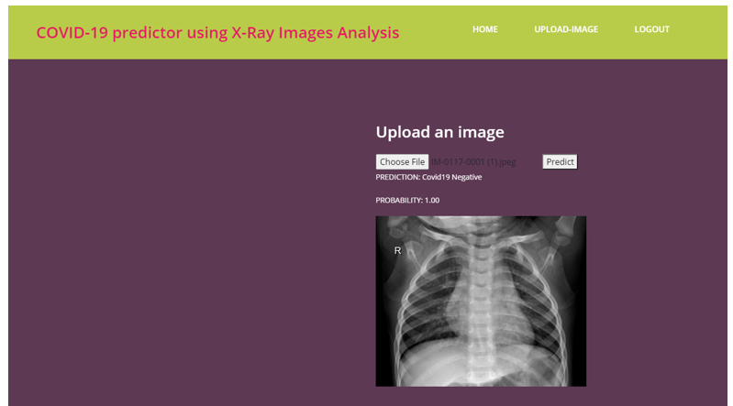

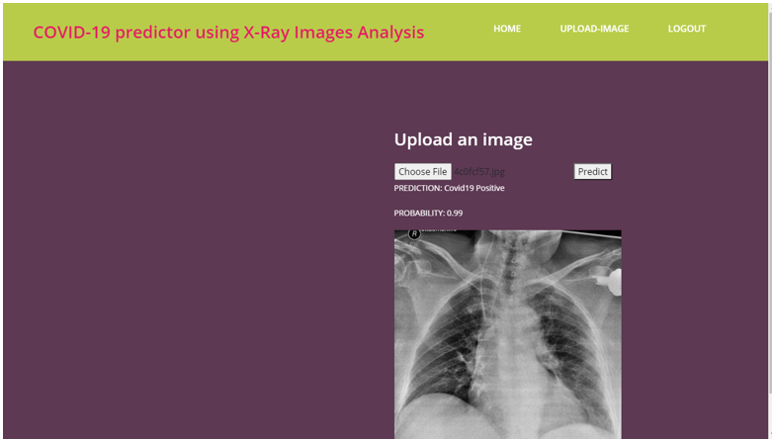

Graphical Report

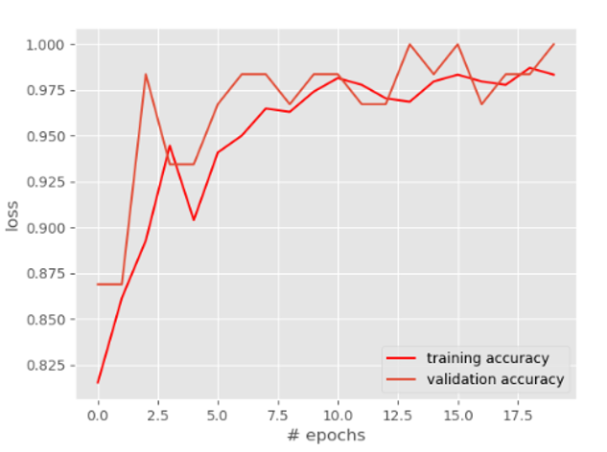

**Extension Idea:**

In future this application can be extended to a real time model, where X-ray of people are taken and the results are generated immediately which can be very useful in airports when people travels to different countries.